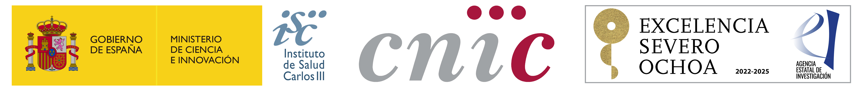


2023

DOCUMENT OF ACCEPTANCE

Participant Information
Name | Middle name(s)
Surname (s) | NIF/NIE / Passport
IBAN Account number

Laboratory where the candidate has been accepted
Scientist-supervisor | Research Line

Dates of training period
Starting date (please choose amongst July 1 or 16 and August 1) in agreement with your CNIC scientist supervisor) | Finishing date

Date and Signature with digital certificate of supervisor | Date and Signature with digital certificate  of participant

Complete this form and send it to the e-mail address: Training_program@cnic.es

In accordance with the provisions of the Organic Law 3/2018 of December 5 on the Protection of Personal Data, and Regulations (UE) 2016/679 related to the Protection of Personal Data we inform you that personal data collected will be incorporated into an automated file called HR registered in the Spanish Agency of Data Protection under the ownership of the CNIC, its purpose being to process your registration and participation in this call, as well as to track your career and professional training by sending different corporative material of the Centre to the address you provided. There is no expectation of the transfer of personal data to any third party outside CNIC. You may exercise your right to object to the treatment described, as well as the rights of access, rectification and deletion of information provided to the Centre by contacting at protecciondedatos@cnic.es. The processing of your personal information as described in the previous section is necessary for the Centre to manage your registration in this training event, without which, the inscription will not be possible.
More information at https://www.cnic.es/en/privacy

